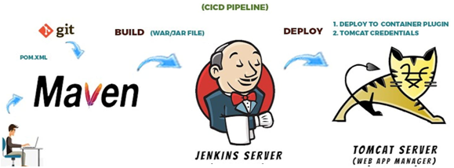

* **Launching Jenkins on EC2 Instance**: The first step was setting up an EC2 instance on AWS and installing Jenkins to facilitate continuous integration and deployment.

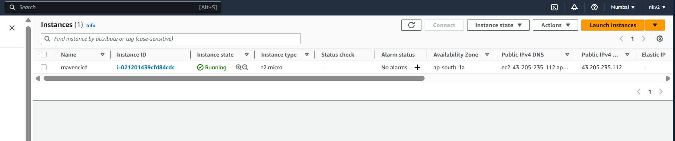

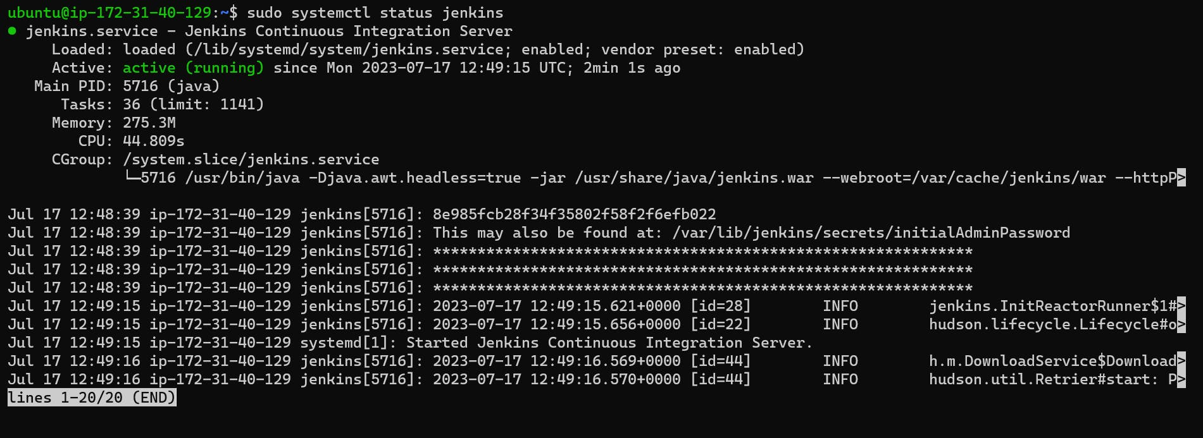

* **Installing and Configuring Maven:** To manage dependencies and build the project, I installed Maven, a popular build automation tool, and configured it to ensure smooth project compilation.

Install Maven Commands

------------------

cd /opt/

1) sudo wget http://www-eu.apache.org/dist/maven/m...

2) sudo tar -xf apache-maven-3.5.3-bin.tar.gz

3) sudo mv apache-maven-3.5.3/ apache-maven/

4) sudo update-alternatives --install /usr/bin/mvn maven /opt/apache-maven/bin/mvn

Configuring Apache Maven Environment

$ cd /etc/profile.d/

$ sudo nano maven.sh

###################################################

# Apache Maven Environment Variables

# MAVEN_HOME for Maven 1 - M2_HOME for Maven 2

export JAVA_HOME=usr/lib/jvm/java-11-openjdk-amd64

export M2_HOME=/opt/apache-maven

export MAVEN_HOME=/opt/apache-maven

export PATH=${M2_HOME}/bin:${PATH}

sudo chmod +x maven.sh

sudo source maven.sh

maven is successfully configured. when we type mvn --version it should display it version everywhere in the system.

**1.Install maven plugin and configure jenkins for maven Manage Jenkins-plugins-maven integration**

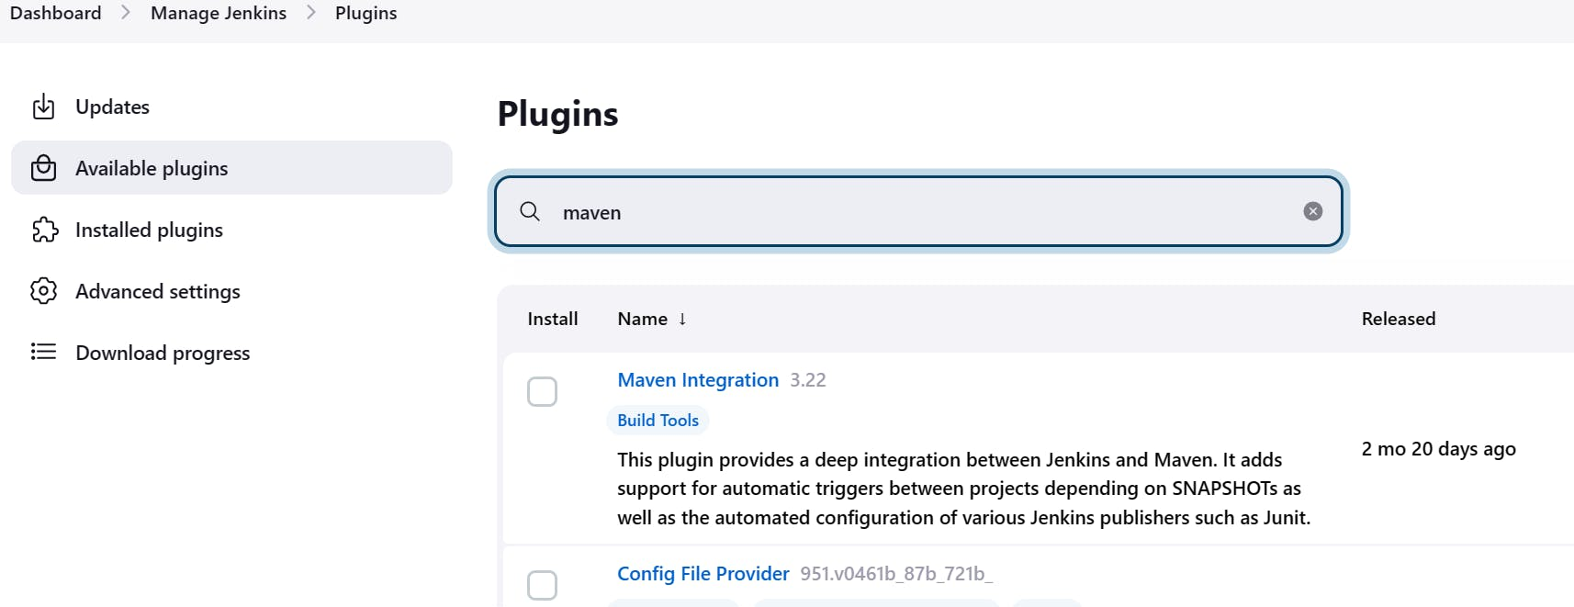

**Set maven path in Jenkins**

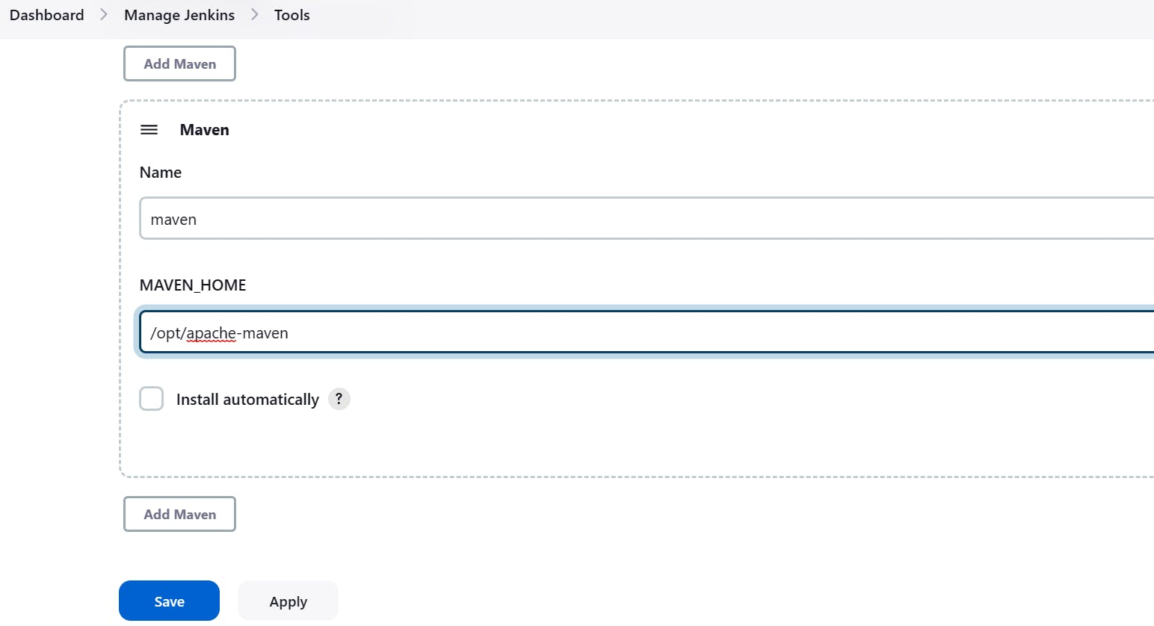

* **Setting up JDK:** Java Development Kit (JDK) was installed to enable Java development on the EC2 instance.

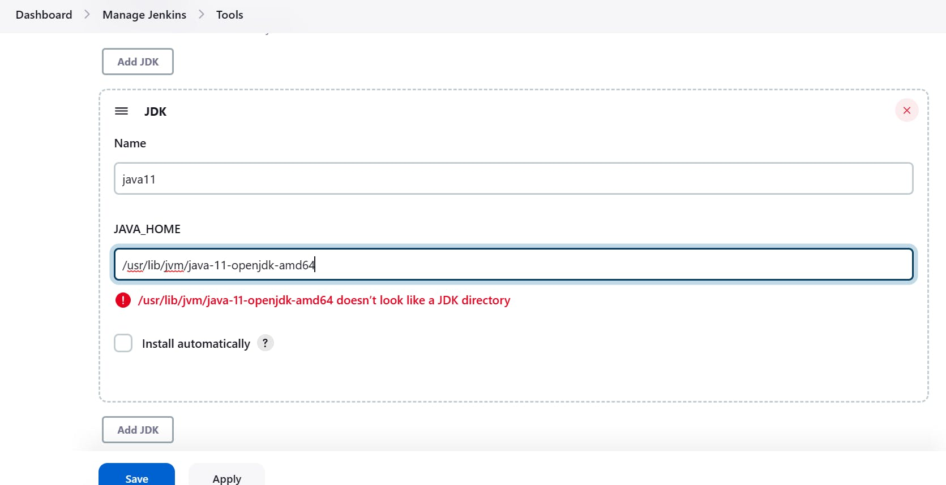

* **Integrating Jenkins with GitHub:** I connected Jenkins to my GitHub repository, allowing it to trigger automated builds and deployments whenever new code changes were pushed.

**Install git in Ubuntu**

sudo apt-get install git

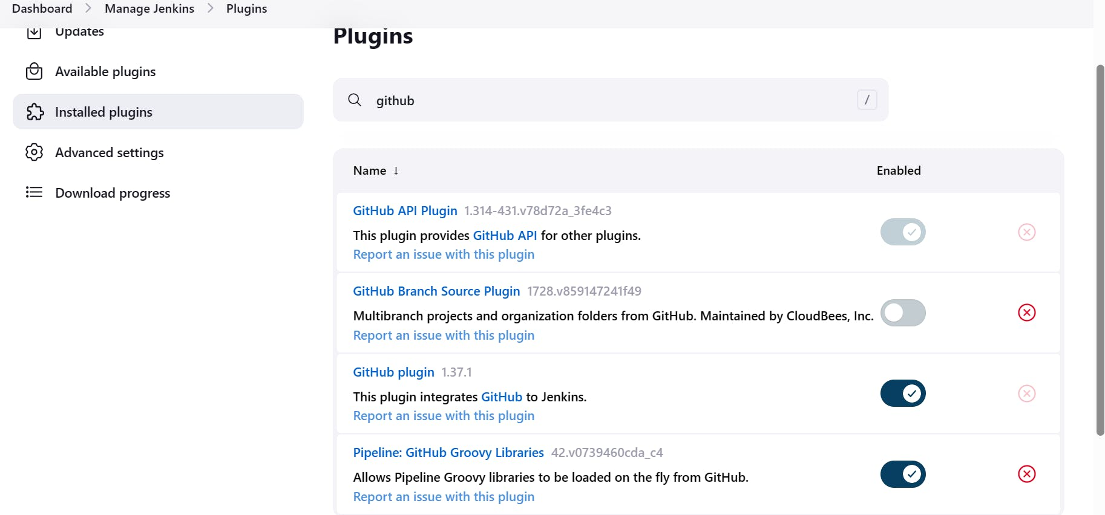

* **Setup Tomcat Server 🐈:** Next, I installed and configured Tomcat, a widely used web server, and servlet container, on the same EC2 instance to host our JSP application.
* **Integrating Tomcat with Jenkins:** I integrated Tomcat with Jenkins, enabling seamless application deployment to the Tomcat server during the build process.

**Install Tomcat**

cd /opt

wget <https://downloads.apache.org/tomcat/tomcat-10/v10.1.11/bin/apache-tomcat-10.1.11.tar.gz>.

tar -xvzf apache-tomcat-10.1.11.tar.gz

mv apache-tomcat-10.1.11 tomcat

cd tomcat/

cd bin

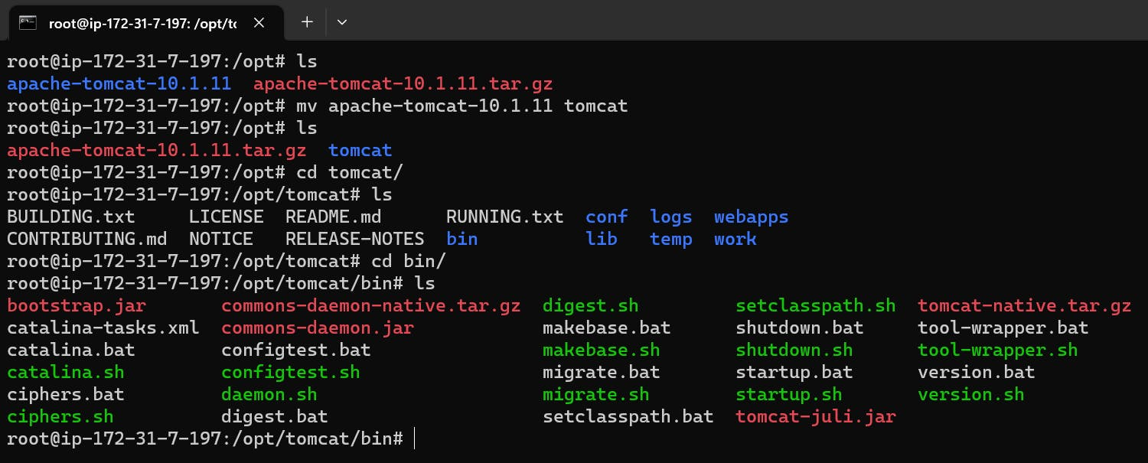

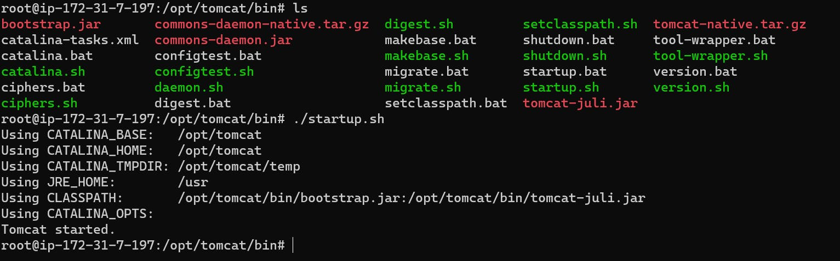

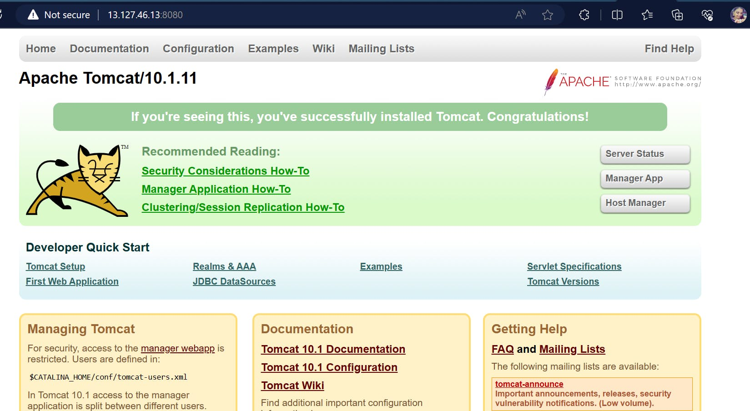

* **Deploying the JSP App to Tomcat:** Leveraging Jenkins, I set up the deployment process to automatically push the JSP web app to Tomcat after successful builds.
* **Poll SCM:** To ensure timely updates, I configured Jenkins to poll the GitHub repository for changes periodically, triggering builds and deployments as needed.